

RADESIGN, w/ ZOOOM hanging on for her life

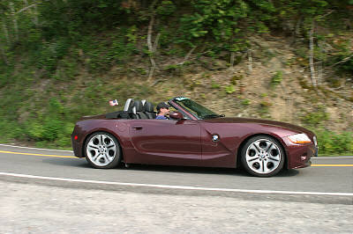

RichNYC



Z3RiffRaff
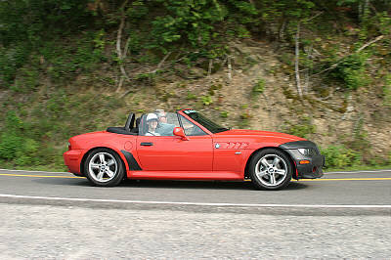

Dave & Gail



Eric & Devin (nice smile)



Ma and Pa Weathers

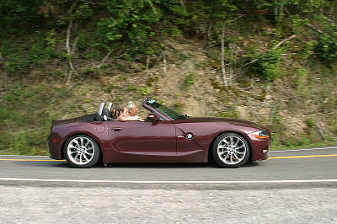

Michelle & Don made the last page (9) YaHoo!

  
  zoom photo
  
  zoom photo
  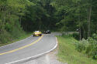
  zoom photo
  
  zoom photo
  
  zoom photo
  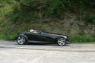
  zoom photo
  
  zoom photo
  
  zoom photo
  
  zoom photo
  
  zoom photo
  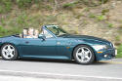
  zoom photo
  
  zoom photo
  
  zoom photo
  
  zoom photo
  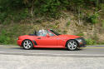
  zoom photo
  
  zoom photo

Was not able to find the first group (Ed, Than & Wah) Perhaps they were
”so fast” that the cameraman couldn’t capture them? Sometimes it pays to be half-fast! Believe it or not, we had a blast too!

-man 



and I thought I cut corners?



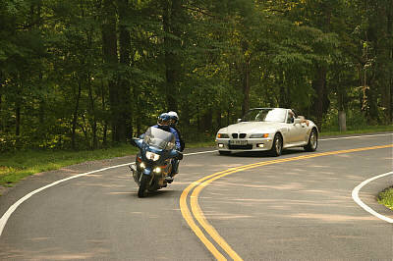

don’t ya hate it when bikers hold you back?


possible Michelle – Thursday?

